Recap of Current Loop Controls:

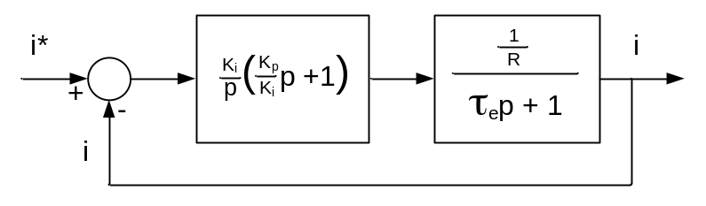
Current Regulation of DC Drive (with Back EMF Decoupled)

Use Proportional plus Integral (PI) Control

G_{c} = K_{p} + = =

with τ_{c} = τ_{e}

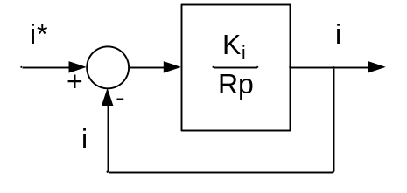
Current Regulation of DC Drive (with Back EMF Decoupled) and Pole/Zero Cancellation

= why choose K_{i} = 2 π f_{bw} R ?

= = ∠ = 0º - tan⁻¹

If R ω = K_{i}

Then

= = = -3dB

Magnitude [dB] | 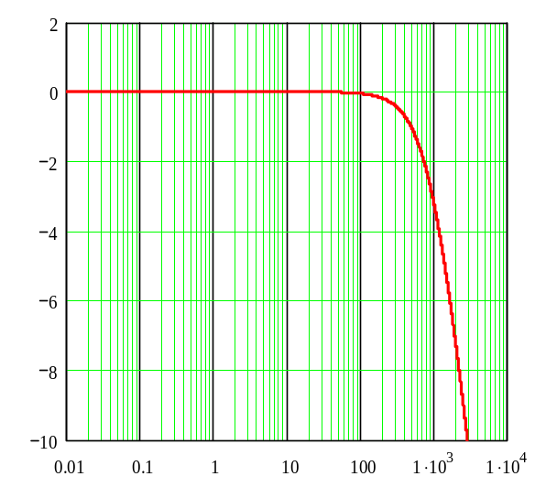  -3 dB @ 1 kHz | Phase [deg] | 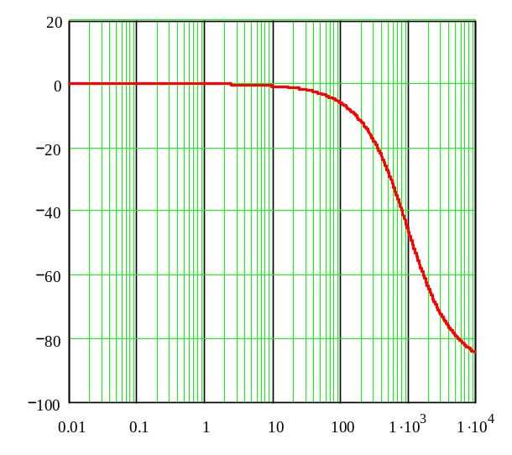  -45º @ 1 kHz
 | Frequency [Hz] |  | Frequency [Hz]
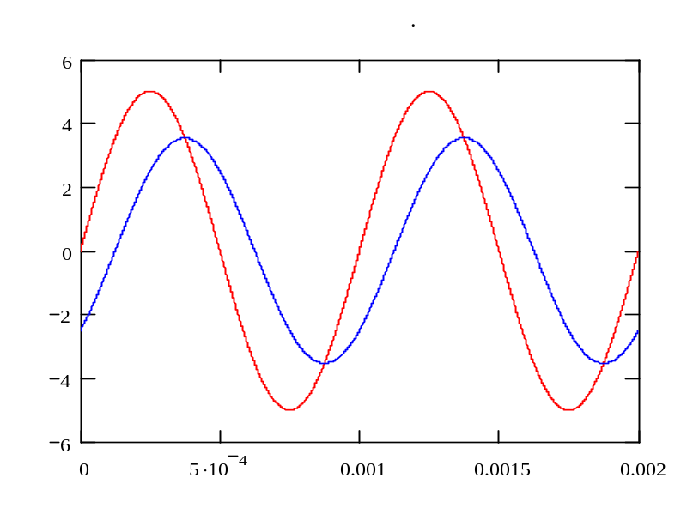
0.707 x 5
5
45º
1 kHz
 | Time [sec]

The gains to tune the current loop at locked rotor conditions are thus:

and

Note: By using Back EMF decoupling, the desired bandwidth can be achieved at no zero speed conditions as well.

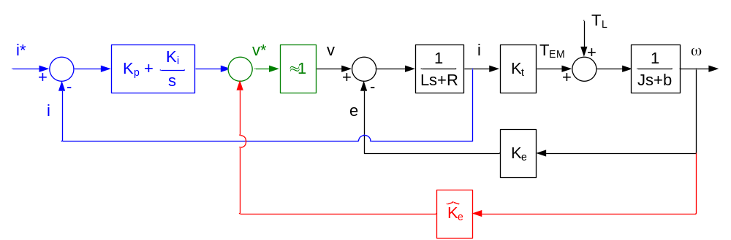
DC Motor PI Current Regulator with Back EMF Decoupling

PowerPoint Slideshow on Current Regulator Tuning.

Machine Equations in the Synchronous Frame:
v = r_{s} i + (p + j ω_{e})l
v = r_{r} i + [p + j(ω_{e} – ω_{r})] l

Scalar Form of the equations for simulating are:

p λ = v - r_{s} i - ω_{e} λ + ω_{e} λ (for decoupling)

p λ = v - r_{s} i + ω_{e} λ - ω_{e} λ (for decoupling)

p λ = v – r_{r} i - (ω_{e} – ω_{r}) λ

p λ = v – r_{r} i + (ω_{e} – ω_{r}) λ

Current Regulation in AC Machines:

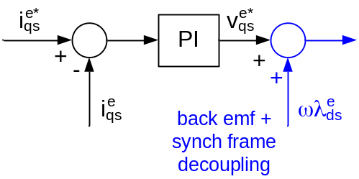 | 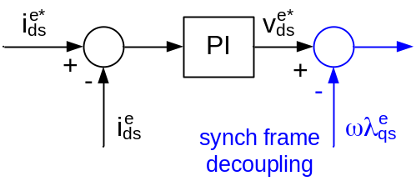
Current Regulation in AC Machines with Back EMF and Synchronous Frame Decoupling

Induction Machine Current Regulation Tuning:

v = r_{s} i + (p + j ω_{e})l

0 = [p + j(ω_{e} – ω_{r})] l + r_{r} i

where
l = L_{s} i + L_{m} i l = σ L_{s} i + l

l = L_{m} i + L_{r} i l = σ L_{r} i + l

We can re-write stator voltage equations as:
v = (r_{s} + p σ L_{s}+ j ω_{e} σ L_{s}) i + p l + j ω_{e} l

We can solve the rotor equation for the time rate of change of rotor flux:

p l = – j(ω_{e} – ω_{r}) l – r_{r} i

eliminate i

Substituting this into stator voltage equation yields:

v = i – j(ω_{e} – ω_{r}) l + j ω_{e} l – r_{r} i

From rotor flux linkage equation:

i = – i

Substituting rotor current into stator voltage equation yields:

v = i – j(ω_{e} – ω_{r}) l + j ω_{e} l – _{e} l

v = i + ω_{rb} l

where

r = ω_{rb} =

In the stator reference frame, there is no cross coupling between d and q axes. In synchronous frame, there is cross coupling.

Voltage control of DC machines

Typical inverter power levels:
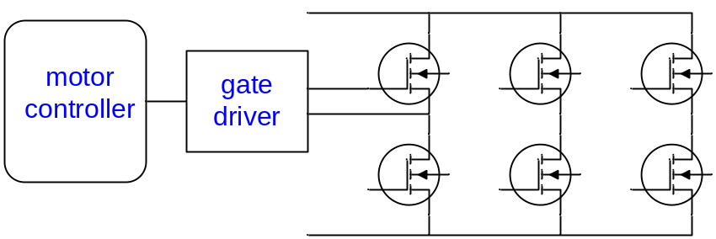
3.3V/100’s mA | +15V/-5V/1-5 Apk | 100’s V/100’s A
Typical Controller Power Sections

Note: There is a big difference between 2Q& 4Q drives!

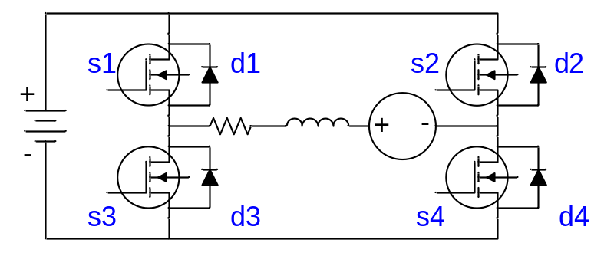 | 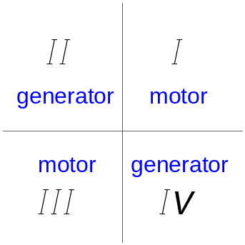

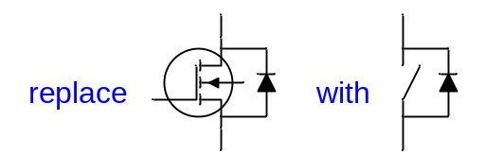

Two quadrant operation in positive direction:

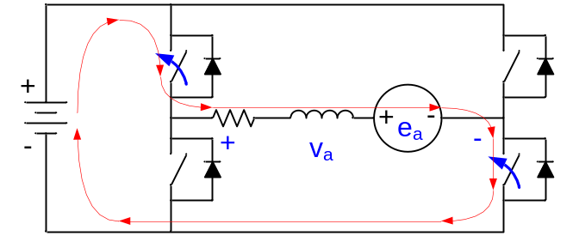 | 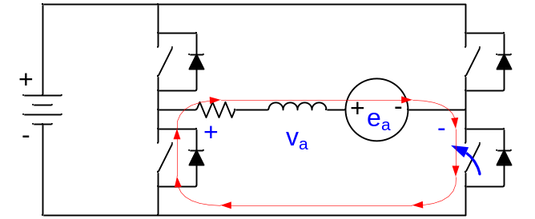
2Q Operation with S1 and S4 On | 2Q Operation with S1 Off and S4 On

With S1 and S4 on (conducting):
v_{a} = +V_{dc}

With S1 off and S4 on, D3 conducts (until current goes to zero):
v_{a} = 0

With S4 on, S1 on for d • T, off for (1-d) • T

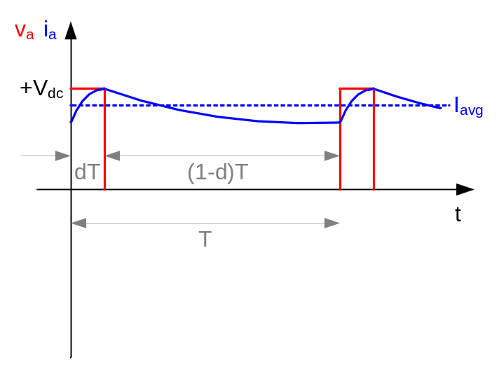 | = = d • V_{dc}  =
2Q Operation

Two quadrant operation in opposite direction:

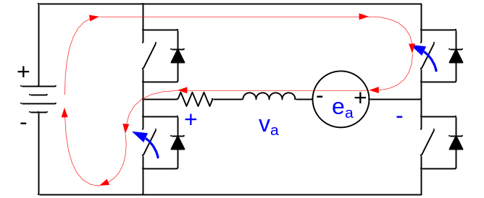 | 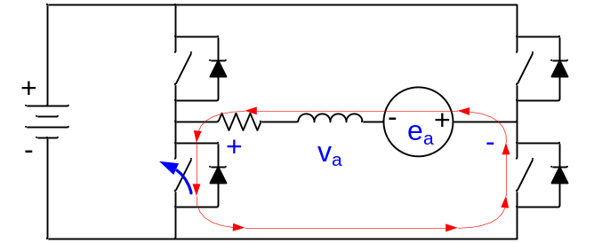
2Q Operation with S2 and S3 On | 2Q Operation with S2 Off and S3 On

Four quadrant operation of a DC drive:
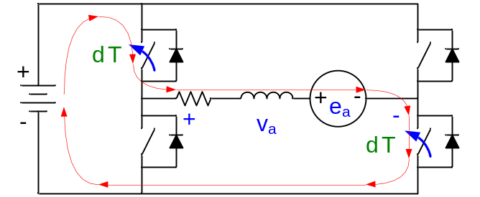 | 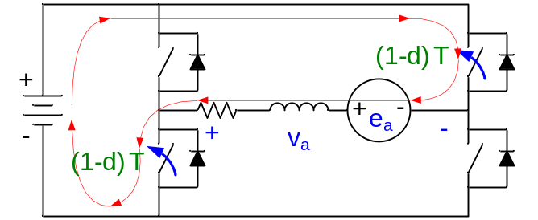
4Q Operation with S1 and S4 On | 4Q Operation with S2 and S3 On

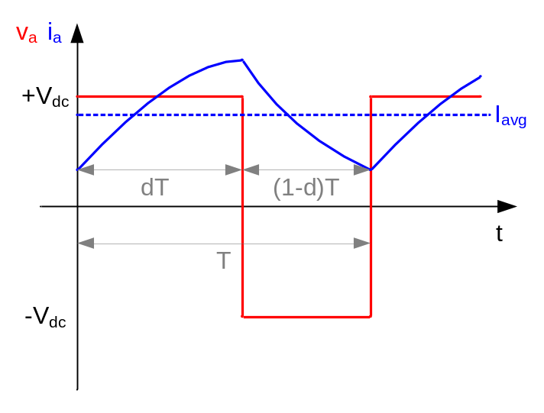 | =  =  = • V_{dc}  =
4Q Operation

Differences between 2Q and 4Q operation:
- 2Q has lower inverter losses due to use of fewer devices
- 2Q has lower motor losses due to lower switching ripple (which can be significant in low impedance machines)
- 4Q used for servo operation (can handle regenerative energy)

Example of switching ripple in 2Q and 4Q drives:

R = 1 Ω L = 1 mH V_{dc} = 100 V I_{avg} = 10 A

f_{s} = 20 kHz → T_{s} = 50 μs

2Q Operation at Stall:

I_{avg} = = → d = = 0.1

1st approximation:
V = L → Δi = = = 500 x 10⁻³ A

Δi_{2Q} = 500 mA

4Q Operation at Stall:

I_{avg} = = → d = + 0.5 = + 0.5 = 0.55

Δi = = = 2.75 A

Δi_{4Q} = 2.525 A > 5 x Δi_{2Q}

2Q Operation | 4Q Operation

Why can’t we dynamically brake in 2Q operation?

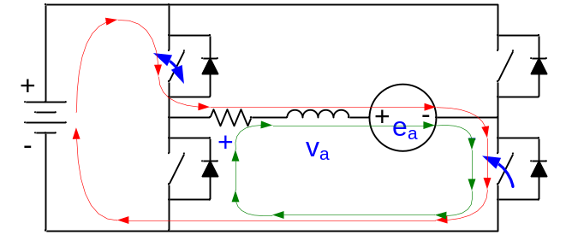 | 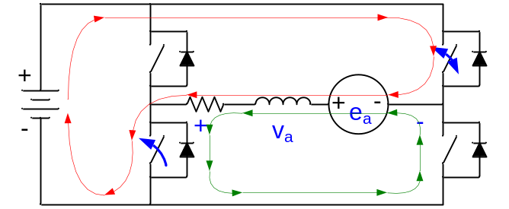
2Q Operation Motoring | 2Q Operation Braking

Motoring | Braking
S1 closed (S4 closed)  v_{a} = R_{a} i + L_{a} + e_{a}  v_{a} - e_{a} = R_{a} i + L_{a}  (exponential growth)  S1 open (S4 closed)  -e_{a} = R_{a} i + L_{a}  (exponential decay) | S2 closed (S3 closed)  v_{a} = R_{a} i + L_{a} - e_{a}  v_{a} + e_{a} = R_{a} i + L_{a}  (exponential growth)  S2 open (S3 closed)  +e_{a} = R_{a} i + L_{a}  (exponential growth!)

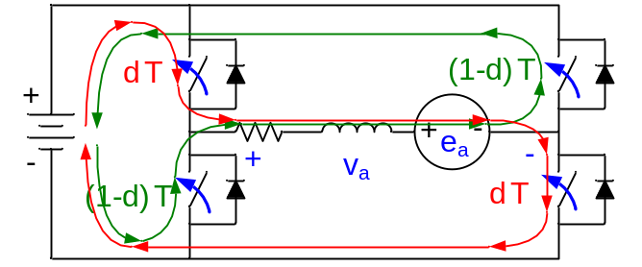  d > (1 – d) | 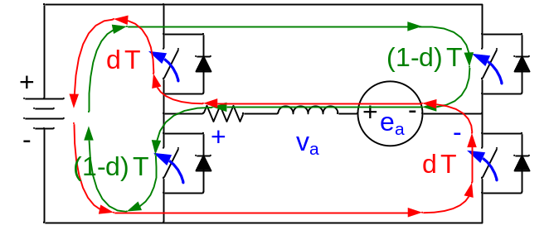 d < (1 – d)
4Q Operation Motoring | 4Q Operation Braking

Brushless DC (BLDC) Drives:

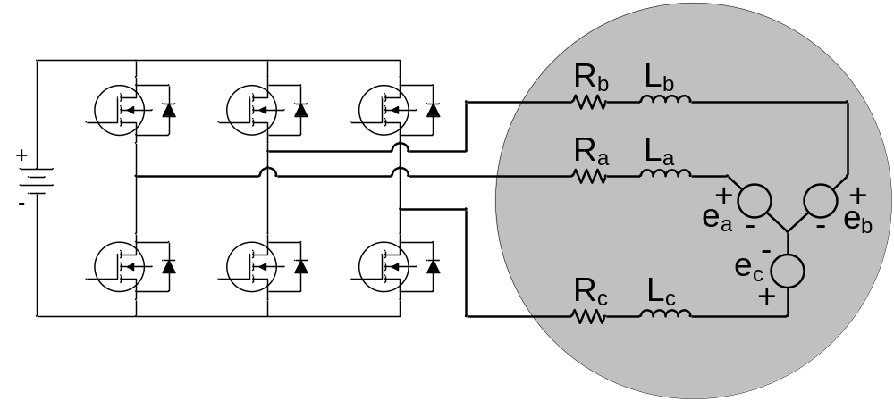
BLDC Drive (Motor and Inverter)

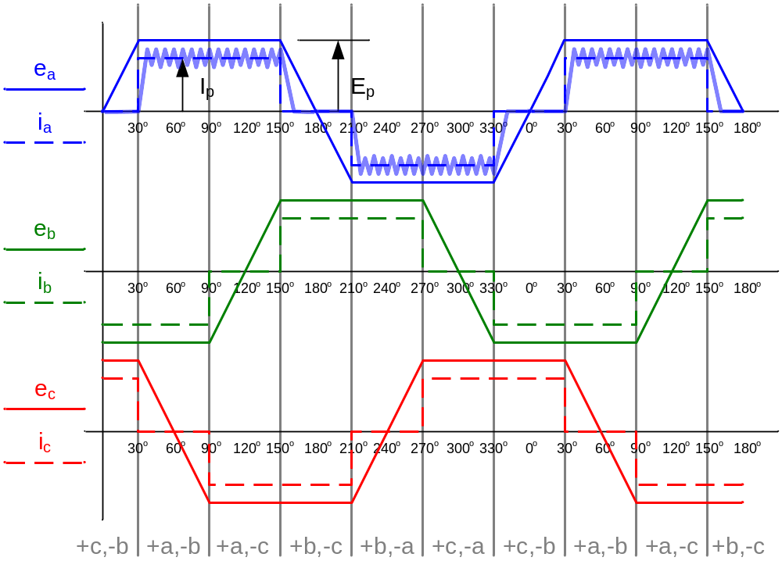
Trapezoidal Back EMF Waveforms

A note on BLDC control chips:

2Q operation is normal
4Q operation is not a true 4Q, but rather a “quasi” 4Q control

Quasi 4Q operation of a BLDC Motor

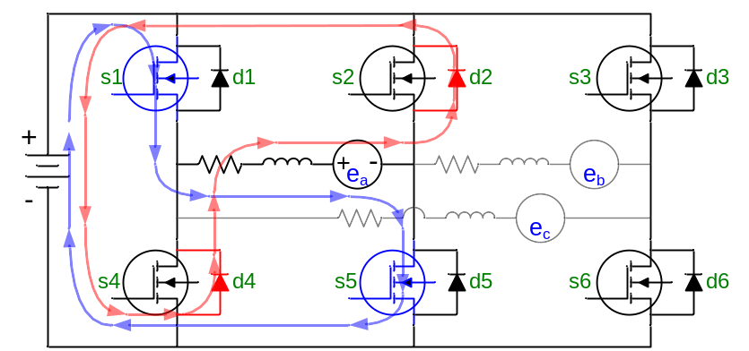
Quasi 4Q Operation of a BLDC Motor

Only PWM S1 and S5 (not S2 and S4). Current freewheels through D2 and D4. Better (lower) switching losses. This introduces duty cycle vs. applied voltage nonlinearity near zero voltage.

4Q | Quasi 4Q
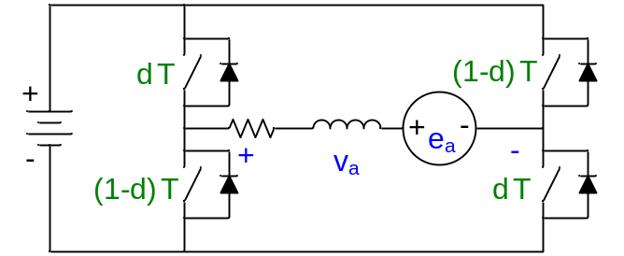 | 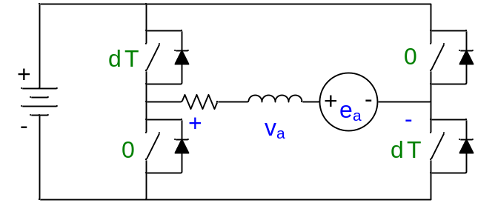
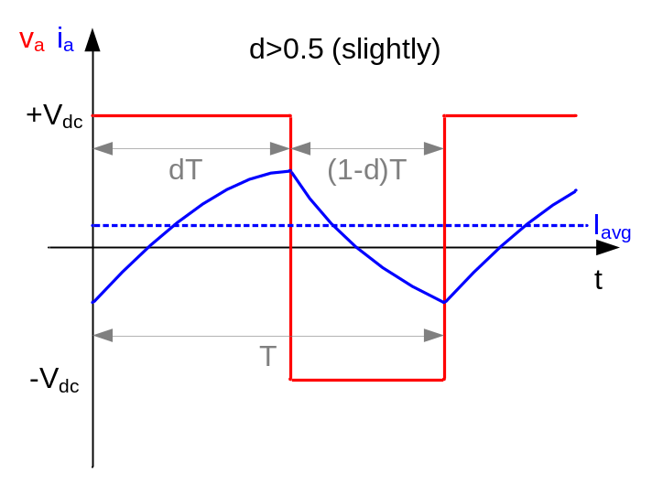 | 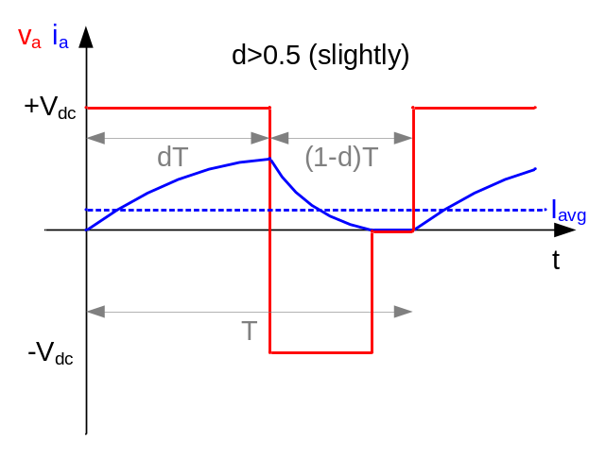
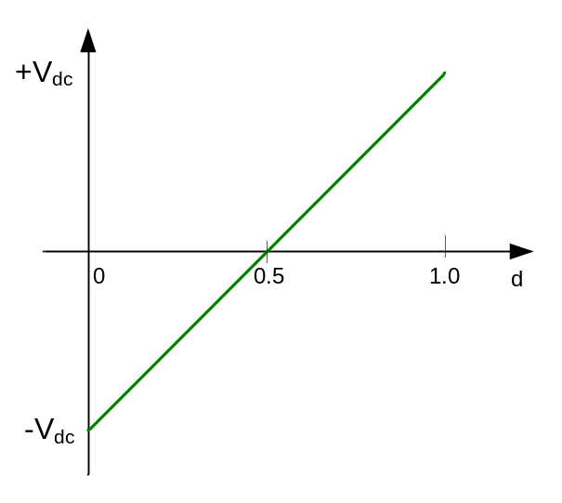 | 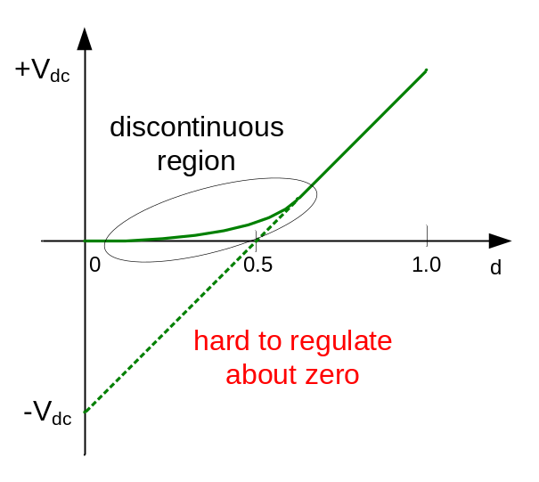

Note: Need D.O.R. (direction of rotation) delay with 2Q and quasi 4Q controllers.

Space Vector PWM in AC Machines:

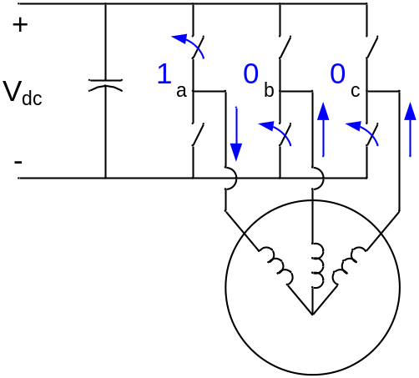 | 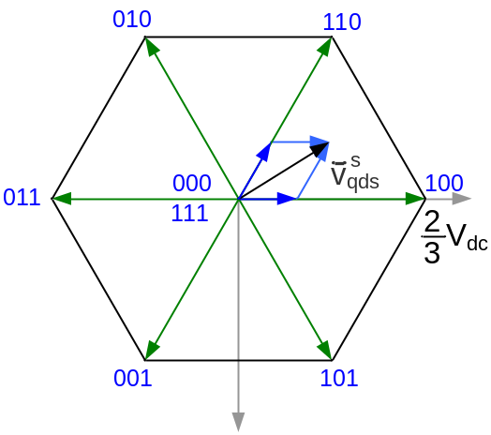
Switching States Used in Space Vector PWM

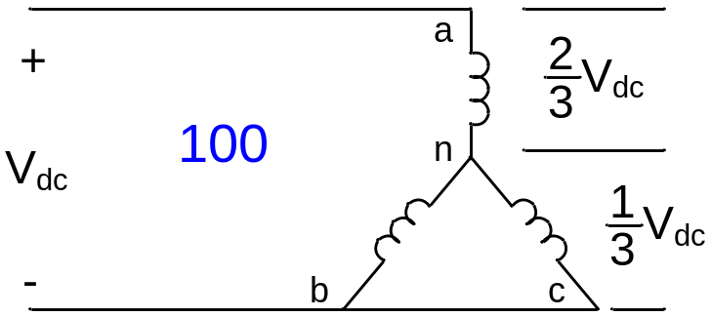 | 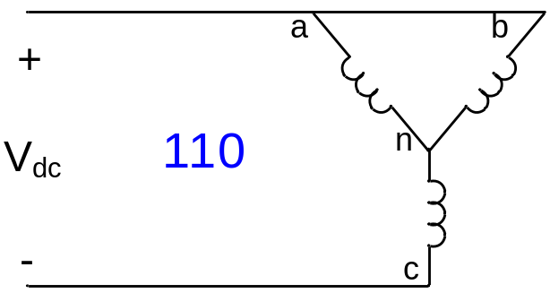
First Two States of Space Vector PWM

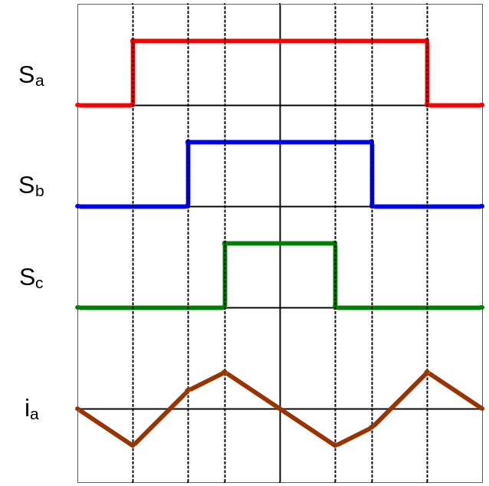
Switching States and Phase Current Ripple in Space Vector PWM Quadrant 1

Review of material from presentation in Lecture 1.

